**“Predicting Stock-Prices using Machine Learning Algorithm”**

**Dissertation-I Report Submitted to**



**Rajiv Gandhi Proudyogiki Vishwavidyalaya, Bhopal (M.P.)**

**Towards Partial Fulfillment for the Award of**

**Master of Technology**

**(Computer Science and Engineering)**

Submitted By:

**Chetna Prasad**

**(Enrollment No 0873CS20MT03)**

Under the Supervision of

**Name of Guide**

(Department of Computer Science and Engineering)

**Department of Computer Science and Engineering**

**Sri Aurobindo Institute of Technology, Indore (M.P.)**

**Session 2021-22**

**Sri Aurobindo Institute of Technology, Indore (M.P.)**

**Department of Computer Science and Engineering**

**RECOMMENDATION**

This dissertation work entitled **“****Predicting Stock-Prices”** being submitted by **“Chetna Prasad (Enrollment No-0873CS20MT03)”** for partial fulfillment of the requirement for the award of **“Master of Technology”** with specialization in **“Computer Science and Engineering”, Sri Aurobindo Institute of Technology Indore** during the year 2021-22 is satisfactory account of his project work under my supervision is recommended for award of the degree.

**APPROVED & SUPERVISED BY:**

**Name of Guide**

(Assistant Professor, Department of Computer Science and Engineering)

**FORWARDED BY:**

**Dr. Praveen Gupta Dr. D.K.Mishra**

(Head, Computer Science and Engineering) (Director, SAIT, Indore)

**Sri Aurobindo Institute of Technology, Indore (M.P.)**

**Department of Computer Science and Engineering**

**CERTIFICATE**

This is to certify that the work embodies in this dissertation entitled **“Predicting Stock-Prices”** being submitted by “**Chetna Prasad” (Enrollment No. – 0873CS20MT03)** for partial fulfillment of the requirement for the award of **“Master of Technology”** in **“Computer Science and Engineering”** to Rajiv Gandhi Proudyogiki Vishwavidyalaya, Bhopal (M.P.), during the academic year 2021-22 is a record of bonafide piece of work, carried out by him under our supervision and guidance in the **Department of Computer Science and Engineering, SAIT, Indore (M.P.)**

**Internal Examiner**  **External Examiner**

**Date:** **Date:**

**ACKNOWLEDGEMENT**

##### I acknowledge my profound indebtedness toward my esteemed guide **Name of Guide ,** Assistant Professor Department of Computer Science and Engineering, Sri Aurobindo institute of technology, Indore, for him valuable guidance, excellent supervision and constant encouragement during the entire course of work.

##### I take this opportunity to thank **Name of HOD** for accepting me to work under him valuable guidance, closely supervising this work, offering many innovative ideas and helpful suggestions, which led to the successful completion of this work. He has kept an eye on the progress of my work and always was available when I needed his advises. His advises and tips helped me a lot in staying at right track. I owe him lots of gratitude for having me shown this way of research.

##### I would like to give thanks to **Dr. D.K.Mishra** for their valuable guidance and motivation for completion of the work.

##### I am thankful to all other faculty members and all staff members in Computer Science and Engineering Department for their help. I am also thankful to my colleagues and friends who helped me directly or indirectly throughout my dissertation work.

##### Last but not least I am thankful to my parents, without their moral support it was impossible for me to complete this work

###### Name of Student-Chetna Prasad (Enrollment No)-0873CS20MT03

###### ABSTRACT:

**TABLE OF CONTENTS**

Recommendations

Certificate

Acknowledgment

Abstract

List of Figures

List of Tables

Abbreviation

**CHAPTER-1: INTRODUCTION Page no**

1.1 Introduction………………………………………………………………………………………………….2

1.2 <Topic Name>…………………………………………………………………………………………………………3

1.2.1 <Topic Name>……………………………………………………………………………………3-6

1.3 <Topic Name>…………………………………………………………………...................................6

1.3.1 <Topic Name> ………………………………………………………7

1.3.2 Classification of shear wall…………………………………………………………………….7-10

1.4 Need of Study ……………………………………………………………………………………………..10

1.5 Objective of Study ……………………………………………………………………………………….10-11

1.6 Summary ………………………………………………………………………………………11-12

**CHAPTER-2: LITERATURE REVIEW**

2.1 General………........................................................................................................14

2.2 Review of literature………………………………………………………………………………………..14-22

2.3 Critiques…………………………………………………………………………………………………………..23

2.4 Problem Formulation……………………………………………………………………………………….23-25

**CHAPTER – 3: Methodology and Modeling Approach**

3.1 General………………………………………………………………………………………………………………26

3.2 Methodology…………………………………………………………………………………………………… 26

3.2.1 Description of technology…………………………………………………………………………27

3.2.2 <Topic Name>……………………………………………………………………………….27-28

3.2.3 <Topic Name>………………………………………………………………………………….28-29

3.3 <Topic Name>……………………………………………………30

3.3.1 Lateral displacement……………………………………………………………………………30

3.4 Summary………………………………………………………………………………………….31

**CHAPTER – 4: CONCLUSION**

6.1 Conclusion……………………………………………………………………………………………………………..84-85

References..............................................................................................................88-90

**LIST OF FIGURES**

|  |  |  |
| --- | --- | --- |
| **S.No** | **Title of Figure** | **Page No.** |
| 1 | Reading stock Data from yahoo Finance |  |
| 2 | An Example of Decision tree |  |
| 3 | Fetching Data using Python |  |
| 4 | Data Set |  |
| 5 | Dataset Details fetched using Yahoo Finance |  |
| 6 | Information of Dataset |  |
| 7 | Closing price of stocks throughout the year |  |
| 8 | Volume of Stocks sold throughout the year |  |
| 9 | Closing prices with Moving Average |  |
| 10 | percent change for each day |  |
| 11 | average daily return |  |
| 12 | Relationship between the daily returns of the stocks |  |
| 13 | Correlation between Close Price(Starting five values) |  |
| 14 | Correlation Plot for Daily Returns |  |
| 15 | Risk in investing in a particular stock |  |
| 16 | Apple Finance data for prediction |  |
| 17 | Close Price Graph of Apple. |  |
| 18 | Fetching Closing Price for prediction |  |
| 19 | Datdataframe created using the Closing price |  |
| 20 | Training Data |  |
| 21 | Prediction usingLSTM |  |
| 22 | Prediction using Decision Tree |  |
| 23 | Prediction using SVM |  |

**LIST OF TABLE**

|  |  |  |
| --- | --- | --- |
| S.No | Title | Page No. |
| 1 | Literature Survey |  |
|  |  |  |
|  |  |  |
|  |  |  |
|  |  |  |
|  |  |  |
|  |  |  |
|  |  |  |
|  |  |  |
|  |  |  |
|  |  |  |
|  |  |  |
|  |  |  |
|  |  |  |

**LIST OF ABBREVIATIONS**

|  |  |
| --- | --- |
| SVM | Support Vector Machines |
| LSTM  ML | Long Short Term Memory  Machine Learning |
| AI | Artificial Intelligence |

**1.ABSTRACT**

Stock buying/selling is very important in finance world. Trying to determine the upcoming prices of the stocks is known as the Stock-Price-Prediction. Mostly peoples think that the stock market is a gamble but it is not true, it is the researched prediction. Stock market can be predicted with well researched approach. This project focuses on comparing the existing Machine-Learning-algorithms such as Support-Vector-Machines(SVM), Long-Short-Term-Memory(LSTM) and Decision-Tree for stock price prediction using Python as programming language. Here ML(Machine-Learning) algorithms is proposed. Trained using the previous year data to predict the future prices of the stocks. The data used is from yahoo Finance. Algorithms such as Support Vector Machine (SVM), Long-Short-Term-Memory (LSTM), and Decision-Tree are used to predict prices of stocks. Apple’s stock data of last eight to nine years is taken and make predictions of the hundred days.

1. **INTRODUCTION**

Basically, most stock traders in the stock market deals in a way such that they purchase stocks at cheaper value and then get rid of them at a higher value. The practice of stock market predictions is not new but the problem is still existence conferred by many of organizations all over the globe. There stands two kinds of stock-analysis that investors do before investing into the stock market,

1. The basic analysis: In this type of analysis investors sees the inside value of the shares, the performance of the industry, the economy of the country and political conditions etc. to determine that whether we have to invest in that stock or not.
2. Technical analysis: Technical analysis is the appearance of the stocks in the form of studying statistical patterns made on market activity, such as past prices and ups and downs in the prices.

Now a-days, Machine learning is widely used in all the Industries. Many traders are applying machine learning in trading and getting really good results.

Here we will develop a monetary information indicator programme in which all chronicled stock costs and information will be stored in a dataset and preserved as preparing sets for the programme. The foremost goal of the forecast is lessen the risk of being exposed to the speculative dynamic.

The random walk is followed by the stock market, implying that the current value is the only thing you can anticipate about the future value. Without a doubt, calculating stock records is difficult due to market volatility, which necessitates a detailed conjecture model. The stock market lists are extremely volatile, which has an effect on the financial backer's trust. Because of the fundamental structure of the monetary space and, to some extent, because of the mix of established limits (previous day's end value, P/E ratio, and so on) and obscure variables, stock prices are seen as volatile and vulnerable to rapid adjustments (like Election Results, Rumors and so on).

AI has been utilized in various endeavours to gauge stock cost. Each examination undertaking's accentuation varies significantly thereby.

(1) The objective value change can be present moment (not exactly a moment), long haul (months after the fact), or close term (not exactly a moment).

(2) The assortment of stocks can be restricted to under 10 explicit stocks, stocks in a particular market, or all stocks.

(3) The indicators utilized will shift from world news and financial patterns to explicit business attributes to unadulterated securities exchange time arrangement insights.

The goal for a likely stock market forecast may be the potential stock price, price uncertainty, or market pattern. There are two forms of forecast: dummy and real-time prediction, which are both found in stock market prediction systems. They also established several rules in Dummy prediction and used the average price to forecast the future price of shares. In order to make a real-time forecast, you could use the internet to look up the stock price of the company's stock.

Deep learning methods for predictive applications in capital markets have been introduced as a result of computational developments. We use a Machine Learning technique in this article, i.e., iSupport ivector iMachine(SVM) iiniorderitoipredict ithe istock imarket iand iwe iare iusing iPython ilanguage ifor iprogramming.

1. **LTRATURE SURVEY**

|  |  |  |  |  |
| --- | --- | --- | --- | --- |
| **S. No.** | **Title** | **Author** | **Year** | **Summary** |
| 1. | Ross S. Economic forces and the stock market. Journal of Business | Chen N | 1986 | Proposed a joint model by imbedding the SVM within the various techniques of classification Among all predicting methodologies, the combining model performs the best. |
| 2. | Introduction to financial forecasting. Applied Intelligence | Abu-Mostafa YS, Atiya AF | 1996 | They show how to use neural networks as a learning paradigm to describe numerous ways for selecting inputs, outputs, and error functions. They also address the learning from hints technique, which is utilised in addition to the traditional approach of learning by examples. They demonstrate how to use suggestions to trade the US Dollar against the British Pound, German Mark, Japanese Yen, and Swiss Franc., over a durationn of 32 months. |
| 3. | Classification Properties of Support Vector Machines for Regression | N. Ancona | 1999 | For monetary guaging applications, analyze Vapnik's help vector machine (SVM) with different methodologies like backpropagation and Radial Basis Function (RBF) Networks. Factual learning hypothesis supports the SVM calculation's hypothesis. The trouble of preparing SVMs is a quadratic programming (QP) challenge. Likewise preset are fundamental computational discoveries for stock value expectation. |
| 4. | Financial time series forecasting using support vector machines | K. jae Kim | 2003 | Examines the feasibility of applying SVM in financial forecasting by comparing it with back-propagation neural networks and case-based reasoning. The experimental results show that SVM provides a promising alternative to stock market prediction. |
| 5. | Forecasting stock market movement direction with support vector machine” | Wei Huang, Yoshiteru Nakamori, Shou-Yang Wang, | 2005 | Looks at SVM to back-spread neural organizations and case-based thinking to check whether it tends to be utilized in monetary determining. The aftereffects of the examinations show that SVM is a likely choice to financial exchange guaging. |
| 6. | Comparison of support vector machines and back propagation neural networks in forecasting the six major Asian stock markets. | Chen, W-H. & Shih, J.Y. | 2006 | This research applies Support-Vector Machines (SVMs) and Back Propagation (BP) neural networks for six Asian stock markets and the experimental results showed the superiority of both models, compared to the early researches. |
| 7. | A quantitative stock prediction system based on financial news | Robert P. Schumaker, Hsinchun Chen | 2009 | This investigation utilizes Support-Vector Machines (SVMs) and Back Propagation (BP) neural organizations to dissect six Asian financial exchanges, and the discoveries uncover that the two models beat past examinations.  Stocks parceled by Sectors were discovered to be the most unsurprising as far as Closeness, with a MSE score of 0.1954 and an extended Directional Accuracy of 71.1.% and a Simulated Trading return of 8.50% (compared to 5.62% for the S&P 500 index). In direct comparisons to existing market experts and quantitative mutual funds, our system's trading return of 8.50% outperformed well-known trading experts. Our system also performed well against the top 10 quantitative mutual funds of 2005, where our system would have placed fifth. When comparing AZFinText against only those quantitative funds that monitor the same securities, AZFinText had a 2% higher return than the best performing quant fund |
| 8. | Stock Market Forecasting Using Machine Learning Algorithms | Shunrong Shen, Haomiao Jiang, Tongda Zhang | 2012 | Proposed utilizing information from a few worldwide monetary business sectors related to AI calculations to estimate stock file changes. |
| 9. | Data mining and neural network techniques in stock market prediction: a methodological review | Debashish Das and Mohammad Shorif Uddin | 2013 | Examining if two well-known approaches, neural networks and data mining, can be used to anticipate stock market movements. When both of these strategies are used together, the prediction may be greatly improved.  dependable |
| 10. | Stocks market prediction using Support Vector Machine | Z. Hu, J. Zhu, Ken Tse | 2013 | Give a hypothetical and experimental establishment for utilizing Support Vector Machines to estimate the financial exchange. For additional stock multivariate investigation, four organization explicit and six macroeconomic components that may affect the stock development are first picked. Second, the Support Vector Machine is used to inspect the connection between these factors and gauge stock execution. Buildup Results suggest that SVM is a powerful predictive tool for stock predictions in the financial market. |
| 11. | A Machine Learning Model for Stock Market Prediction | Osman Hegazy, Omar S. Soliman and Mustafa Abdul Salam. | 2013 | This work suggested a machine learning model for stock price prediction using financial technical indicators that incorporates the particle swarm optimization (PSO) technique and the LS-SVM. |
| 12. | Adaptive selection of US stocks with neural nets. In: Deboeck GJ, editor. Trading on the edge: neural, genetic, and fuzzy systems for chaotic financial markets. New York: Wiley | Hall JW | 2017 | Specialists from the world's biggest monetary foundations teamed up to this undertaking, which has effectively included bleeding edge innovation. To expand benefit, this book discloses how to utilize neural organizations, calculations, fluffy rationale, and nonlinear information preparing approaches. The latest logical disclosures, their effect on current money hypothesis and practice, just as the most productive strategies to utilize them They're all covered, from any trading and portfolio management system. |
| 13. | Stock Market Prediction Using Machine Learning | V Kranthi Sai Reddy1 | 2018 | Recommended that information from a few worldwide monetary business sectors be joined with AI calculations to conjecture stock list changes. The SVM calculation works with an immense dataset of qualities assembled from a few overall monetary commercial centers. Besides, SVM doesn't have the issue of overfitting. For expecting the day by day pattern, many AI based calculations have been introduced. |
| 14. | Exploring Models and Data for Remote Sensing Image Caption Generation | Xiaoqiang Lu, Binqiang Wang, Xiangtao Zheng, and Xuelong Li. | 2018 | investigate to describe the remote sensing images with accurate and flexible sentences. Extensive experiments on the proposed data set demonstrate that the content of the remote sensing image can be completely described by generating language descriptions. Stocks on the Stock Exchange The remarkable efficiency is supported by numerical data. Our well-trained predictor was used to create realistic trading models. In comparison to the chosen benchmarks, the model yields a bigger profit. |
| 15. | Stock Market Data Prediction Using Machine Learning Techniques detection. | Edgar P. Torres P, Myriam Hernández Álvarez, Edgar A. Torres Hernández, and Sang Guun Yoo. | 2018 | This research investigates how historical data and machine learning algorithms may be used to anticipate stock market values. Experimented with stock market data from Apple Inc. to anticipate closing prices using random forests and multilayer perceptron algorithms. An accuracy study was also carried out to see how beneficial these sorts of supervised machine learning algorithms are learning algorithms could be in the financial field. |
| 16. | Stock Market Prediction using Linear Regression and Support Vector Machines | Vaishnavi Gururaj, Shriya V R and Dr. Ashwini K | 2019 | Support Vector Machines (SVMs) have advanced features such as high accuracy and predictability. This paper survey the pros and cons of using both these techniques to predict values and compare both algorithms. |
| 17. | STOCK MARKET PREDICTION SYSTEM USING MACHINE LEARNING APPROACH | 1Faisal Momin, 2Sunny Patel, 3Kuldeep Shinde, 4Prof.A.C.Taskar | 2019 | In this paper tested using back propagation neural network algorithm with optimization using gradient descent on stock |
| 18. | Stock Market Prediction Using Machine Learning Algorithms | K. Hiba Sadia, Aditya Sharma, Adarrsh Paul, SarmisthaPadhi, Saurav Sanyal | 2019 | The arbitrary timberland classifier and the SVM classifier are two of the classifiers used here for financial exchange expectation. |
| 19. | Automated Stock Price Prediction Using Machine Learning | Mariam Moukalled Wassim El-Hajj Mohamad Jaber | 2019 | developed a stock price trend prediction system.  AI framework mainly  incorporate DNN, RNN, SVR and SVM for prediction. Tested proposed prediction model on APPL, AMZN, GOOGL and FB stock shares, resulting in a 82.91% accuracy. |
| 20. | Stock market prediction using machine learning and deep learning techniques | Prerana C1, Pratheeksha Mahishi J1, N Tahmin Taj1, Anusha B Shetty1, Madhu B R2 | 2020 | Conclude that the use of time series forecasting with the prophet and artificial recurrent neural network that is LSTM (long short term memory) yield in more accurate prediction. |
| 21. | Survey Of Stock Market Prediction Using Machine Learning Approach | ASHISH SHARMA, DINESH BHURIYA, UPENDRA SINGH | 2017 | survey of well-known efficient regression approach to predict the stock market price from stock market data based. |
| 22. | Stock Market Prediction Using Machine Learning Techniques. | Mehak Usmani, Syed Hasan Adil, Kamran Raza and Syed Saad Azhar Ali. | 2016 | The Single Layer Perceptron (SLP), Multi-Layer Perceptron (MLP), Radial Basis Function (RBF), and Support Vector Machine (SVM) AI approaches are differentiated. The discoveries suggest that AI strategies might be utilized to figure the presentation of the KSE-100 file. |
| 23. | Stock Market Prediction Using Machine Learning | 1st Ishita Parmar, 2nd Navanshu Agarwal, 3rd Sheirsh Saxena, Ridam Arora, Shikhin Gupta, Himanshu Dhiman, Lokesh Chouhan | 2018 | The exploration centers around stock worth forecast utilizing relapse and LSTM-based AI. Open, close, low, high, and volume are largely factors to consider. |
| 24. | Stock market prediction using machine learning classifers and social media, news | Wasiat Khan, Mustansar Ali Ghazanfar, Muhammad Awais Azam, Amin Karami, Khaled H. Alyoubi, Ahmed S. Alfakeeh | 2020 | results show that highest prediction accuracies of 80.53% and 75.16% are achieved using social media and fnancial news, respectively. Random forest classifer is found to be consistent and highest accuracy of 83.22% is achieved by its ensemble. |
| 25. | Machine Learning Techniques and Use of Event Information for Stock  Market Prediction: A Survey and Evaluation | Paul D. Yoo, Maria H. Kim, Tony Jan | 2006 | For more precise expectation, fusing occasion data into the forecast model is basic. To give predominant execution in monetary time arrangement forecast, an exact occasion weighting approach and a vigorous robotized occasion extraction framework are required. |
| 26. | Stock Market Prediction Using Hidden Markov  Models | Aditya Gupta | 2012 | To prepare the nonstop HMM, consider the partial change in stock worth just as the stock's intra-day high and low qualities. This HMM is then used to create a Maximum a Posteriori judgment dependent on all plausible stock qualities for the following day. |
| 27. | Textual analysis of stock market prediction using breaking financial news: The AZFin text system | ROBERT P. SCHUMAKER, HSINCHUN CHEN | 2009 | A support vector machine (SVM) derivative designed specifically for discrete numeric prediction and models with various stock-specific variables was used. |
| 28. | Global stock market investment strategies based on financial network indicators using machine learning techniques | Tae Kyun Lee , Joon Hyung Cho , Deuk Sin Kwon , So Young Sohn | 2018 | Inspect the impact and utilization of association pointers by utilizing them as commitments to dynamic frameworks utilizing a couple of AI draws near (essential backslide, support vector machine, and irregular woodland). |
| 29. | Stock market prediction with multiple classifiers | Bo Qian, Khaled Rasheed | 2006 | The Dow Jones Industrial Average record's consistency was examined to uncover that not all periods are similarly irregular. Utilizing the Hurst type, I had the option to pick a period with a serious level of consistency. Auto-common data and bogus nearest neighbor approaches were utilized to heuristically appraise boundaries for creating preparing designs. |
| 30. | Predicting stock market index using fusion of machine learning techniques | Jigar Patel, Sahil Shah, Priyank Thakkar, K. Kotecha | 2014 | In the principal stage, the exploration presents a two-stage combination procedure 26 that incorporates Support Vector Regression. The Neural Network, Random Forest, and SVR expectation models are the second step of the combination strategy. |

Table 1. Literature Survey

**FLOW DIAGRAM**

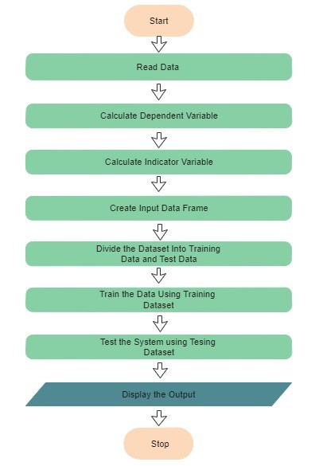

1. **MODULE DESCRIPTION**
   1. **Machine Learning**

Using Machine Learning, Systems will learn automatically through the data provided. It is referred as the subSet of A.I(Artificial-Intelligence). There are so-many Machine learning techniques like Regression, Classification, Neural-Networks etc. Machine learning emphasis on learning themselves through the programs developed.

* 1. **Reading Stock Data**

In this project the data is taken from the Yahoo finance there are the stock data of four companies such as Apple, Amazon, Google and Microsoft are used for data visualization and the prediction is done using the last nine years(from 2012 to the current year) data. The hundred days prediction is done. The data is extracted from yahoo finance using the pandas_datareader Library in python.

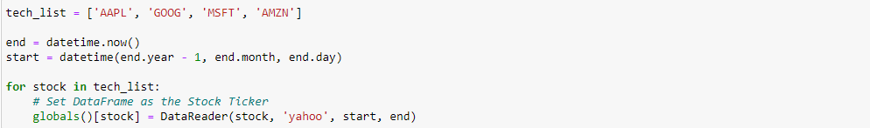

Fig. 1. Reading stock Data from yahoo Finance

AAPL, GOOG, MSFT, AMZN are the tickles, using which we fetch the data from the yahoo finance. And making aur data frane.

* 1. **Dependent Variable**

A Dependent variable is actually what it seems like. It is something that relies upon different variables. For instance, a grade could be a dependent variable since it could change contingent upon a few factors, for example, the amount you considered, how much rest you got the prior night you stepped through the examination, or even how hungry you were the point at which you took it. Normally when you are searching for a connection between two things you are attempting to discover what makes the reliant variable change the manner in which it does.

* 1. **Training Data**

The knowledge that the algorithm learns is based on the observations in the training set. Each observation in supervised learning problems contains an observed output variable and one or more observed input variables.

* 1. **Test Data**

The test data is a collection of observations is used to measure the model's output using a performance metric. It's important that no observations from the training set make the test set. It would be difficult to tell whether the algorithm has learned to generalize from the training set or has merely memorized it if the test set contains examples from the training set.

* 1. **Support-Vector-Machines(SVM)**

A SVMBis a distinctive classificator which is formally described by means of the isolating hyperplane. It's important that no observations from the training set make the test set. It would be difficult to tell whether the algorithm has learned to generalize from the training set or has merely memorized it if the test set contains examples from the training set.

The Support-Vector-Machines(SVM)

The random walk is followed by the stock market, implying that the current value is the only thing you can anticipate about the future value. Without a doubt, calculating stock records is difficult due to market volatility, which necessitates a detailed conjecture model. The stock market lists are extremely volatile, which has an effect on the financial backer's trust. Because of the fundamental structure of the monetary space and, to some extent, because of the mix of established limits (previous day's end value, P/E ratio, and so on) and obscure variables, stock prices are seen as volatile and vulnerable to rapid adjustments (like Election Results, Rumors and so on).

* **Radial-Basis-Function(RBF) Kernel**

The (RBF) Radial-Basis-Function, otherwise called the RBF bit, is a typical bit work in AI. It is utilized in an assortment of kernelized learning calculations. Help vector machine order, indeed, is the place where it is most generally utilized.

A spiral premise work is a genuine esteemed capacity whose worth is exclusively dictated by the separation from the source, or, on the other hand, by the separation from a core. A spiral capacity is any capacity that satisfies the property.

RBF = Local ResponseiFunction

Widely used to smooth images in Signal Processing the RBF Kernel is a low-band pass filter. The RBF Kernel acts as a filter, removing non-smooth solutions.

The RBF-kernel (Gaussian-kernel) is kernel that is shaped like a radial basis function (more generally, a Gaussian-function) (more specifically, a Gaussian function).

The iRBF iunits iprovide ia inew ibasis iset ifor isynthesizing ithe ioutput ifunction. iThe iradial ibasis ifunctions iare inot iorthogonal iand iare iovercomplete.

* 1. **Decision-Tree**

Decision Trees are a form of supervised machine learning in which data is split on a regular basis based on a parameter (you describe what the input is and what the corresponding output is in the training data). The tree can be represented by two entities: decision nodes and leaves. The leaves show the decisions or final outcomes. The information is kept in the decision nodes.

There is always a question which is asked by the decision tree and according to that question the decision tree classifies the entity based on the answers. The decision tree always starts at the top and go down to the bottom until it cant just go further. Below are some terminologies related to the decision tree

* Root Node: it is the top of the tree
* Internal Nodes: this are the nodes between the root node and the leaf nodes. Internal Nodes have both arrows pointing towards them and also pointing away from them.
* Leaf Node: the bottom of the decision tree is leaf Node. The arrows always points towards the leaf Node and not away from them

A Decision tree is Shown below-

[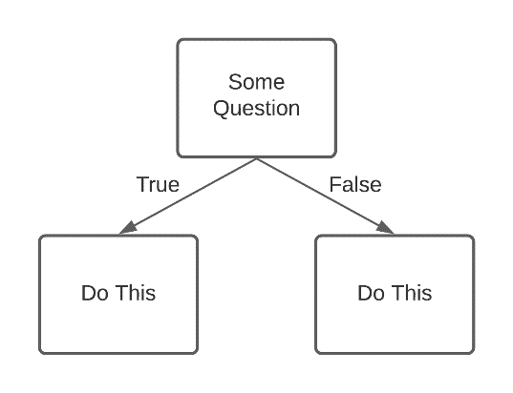](https://lucid.app/documents/edit/282c1783-d677-4c73-a103-39e2dea952b9/0?callback=close&name=docs&callback_type=back&v=277&s=612)

Fig.2 An Example of Decision tree

1. **IMPLEMENTATION**
   1. **Understanding the Objective**

The first step in developing a project is to understand the objective which involves an understanding of the intent and essentials of a system. This comprehension is used as a problem description and a preparatory system to accomplish the expectations. The objective of our project is neither to build a system that makes billions nor to waste billions too. But the objective is to develop a system that finds the direction of change of stock price indices based on the co-relations between stock prices and help the investors in the stock market in taking a decision whether to buy/sell/hold a stock by providing the results in-terms of visualizations.

* 1. **Data Collection**

The Data used are of four companies including Apple, Google, Microsoft and Amazon. The data from the last one year is taken. For data-visualization I am using last year data of the four companies and for prediction I am going to use last eight to nine years of data of Apple Inc.. The data is Fetched using yahoo finance using python library such as pandas-datareader.

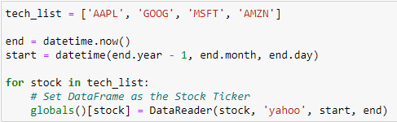

Fig.3 Fetching Data using Python

Because of the ease of this project I used Yahoo Finance data.

The Prediction is done on the closing price since yahoo is already adjusted the closing price we don’t need to do it, We just need to do prediction.

The data set is of the following form-

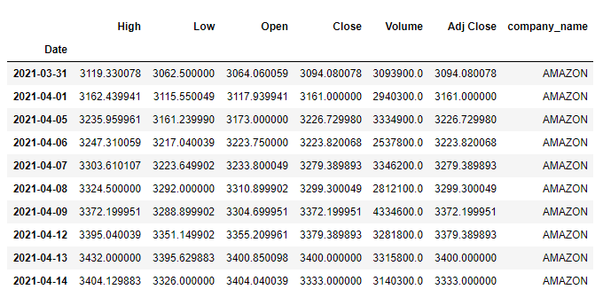

Fig. 4 Data Set

There are seven features in the dataset. This features are as follows-

1. Date: The date when Stock market is open.
2. High: Highest price of the stock on the particular date.
3. Low: Lowest price of the stock at the particular date.
4. Open: The Initial price value of the stock on that particular day.
5. Close: The Final price of the stock at which the stock market is closed.
6. Volume: The Number of the stocks sold on that particular day.
7. Adj. Close: Adjusted Closing Price for the stocks for that particular date.

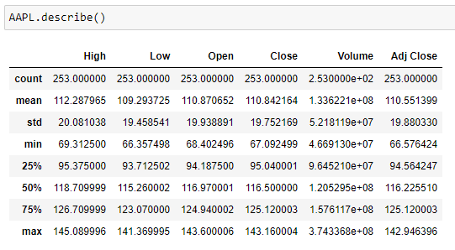

Fig. 5 Dataset Details fetched using Yahoo Finance

* 1. **Preprocessing data**

Preprocessing a data which help us to remove the empty values and fill the missing coloum, Preprocessing approach are work on historical data and provide outcomes of future occurrence. And this is entirely different from data mining process.

As explained , preprocessing clean the data which work on different measure, This is likewise a valuable procedure for experts in promoting industry as it could help choose which battle effectively created income and business. With the end goal of this exploration, Prescient Investigation is useful for the accompanying reason

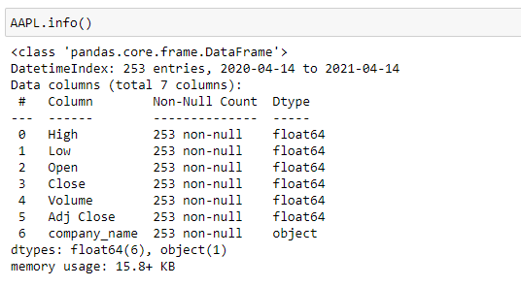

Fig. 6 Information of Dataset

As the Data is fetched from the Yahoo Finance there are no null values. The data we get is already processed all the heavy lifting of data preprocessing of the data is done by yahoo.

* 1. **Data Visualisation**

A digital representation of numerical data is known as data visualisation. We use line maps, candlestick charts, bar charts, and histograms to visualise the outcomes for short-term trading assistance after forecasting stock market movements.

I discovered no irregularities in the datasets, such as no functions that are zero and no inaccurate values due to the presence of negative values. As seen in the illustration below-

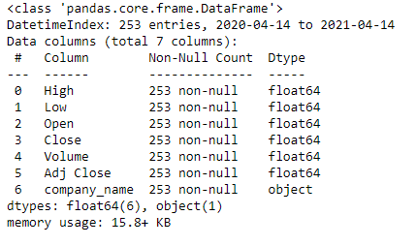

Fig . 6 Information of Dataset

By looking at the dataset we can clearly say that the features which are not important for us and for this project are the features named Date, High and Low. This are not important for us because we don’t need to know what was the highest stock price for that day was or what is the lowest price for the stock on that particular day, We just don’t want this information. The information which is important for us is the Open and Close price for the stock for that particular day because if the Close price is more than the Open price we will have profit and if the close price is less than the Open than we incurred Loss .

For the visualization of the data matplotlib library is used.

* 1. **Prices of the stock Fluctuating overtime**

Here Adj. Close stock price of the for companies i.e. Apple, Google, Amazon and Microsoft(AAPL, GOOG, MSFT, AMZN) with the Date are plotted. Here x-axis shows the time in-terms of year/months/days and y-axis shows the Adjusted Close price values.++

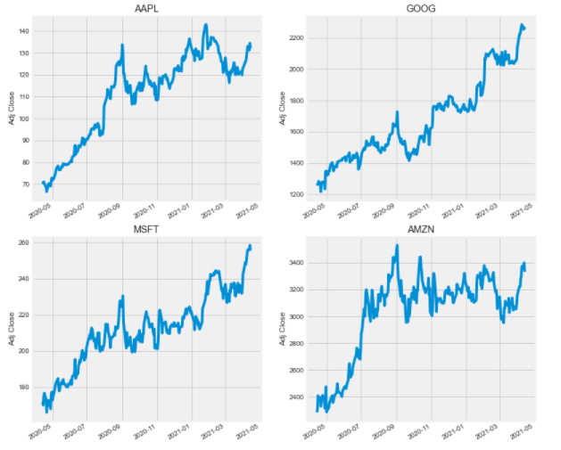

Fig. 7 Closing prices of stocks throughout the year

X-axis: Represents Trading Days

Y-axis: Represents Closing Price In USD

From the above graphs we can visualize that the Closing price of the Apple, Google, Microsoft and Amazon is lowest lowest before 2020-5 and increasing since than with some gradual increase or Decrease throughout the year.

* The highest closing price of Apple is between 2021-01 and 2021-03.
* The highest closing price of Google is between 2021-03 and 2021-05
* The highest closing price of Microsoft is between 2021-03 and 2021-05
* The highest closing price of Amazon is at the starting of 2020-09
  1. **Prices of the stock Fluctuating overtime**

Additionally volume of offer is significant as a rising business sector should see rising volume, i.e, expanding cost and diminishing volume show absence of interest, and this is an admonition of a potential inversion. A value drop (or ascend) on huge volume is a more grounded signal that something in the stock has generally changed.

The volume of stock being traded each day is shown below-

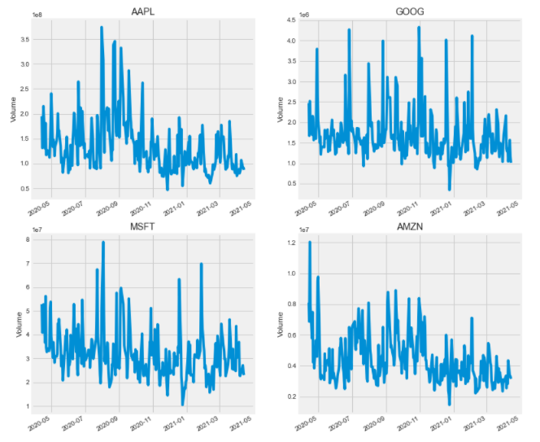

Fig. 8. Volume of Stocks sold throughout the year

X-axis: Represents Tradings Days

Y-axis: Represents Volume of the Stocks

From the above graphs we can visualize that the Volume of the Stocks of the Apple, Google, Microsoft and Amazon. The Volume of the stocks is lowest around 2021-01 and increasing since than with some gradual increase or Decrease throughout the year.

* The highest Volume of Apple is between 2020-07 and 2020-09.
* The highest Volume of Google is somewhere around 2020-11.
* The highest volume of Microsoft is between 2020-07 and 2020-09.
* The highest Volume of Amazon is at the starting of 2020-09.
  1. **Moving Average**

The moving average is calculated for the easy Observation of the flow of the closing prices i.e on some duration the closing price will go up or down. The Moving average is calculated for 10,20 and 50 days. The closing prices against the moving average is shown below-

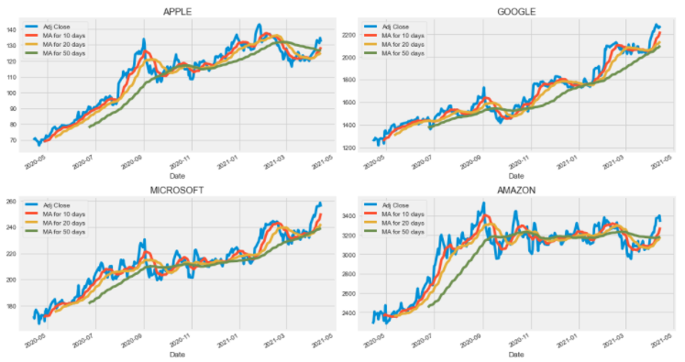

Fig. 9. Closing prices with Moving Average

Blue Line: Actual Closing Price

Red Line: Moving average of 10 days

Orang Line: Moving Average for 20 days

Green Line: Moving Average for 50 days

From the above graphs we can visualize that the Moving average closing price of Stocks of the Apple, Google, Microsoft and Amazon. Clearly we can visualize from the graph that the Closing prices of the each company is gradually increasing as we go forward. And by looking at the moving average of the closing prices of the stocks we can say that the closing price will further go up in upcoming days.

* 1. **Daily -Return of the stock**

Since we've done some example examination, we should don't hesitate to plunge to some degree more significant. We're right now going to take apart the threat of the stock. To do so we'll need to research the consistently changes of the stock, and not just its preeminent worth. What about we don't hesitate to use pandas to recuperate teh step by step returns for the Apple stock.

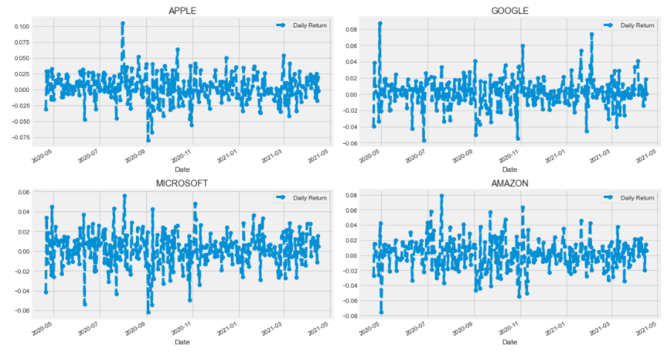

Fig. 10. percent change for each day

x-axis: Date

y-axis: Percentage

The above figures shows the risk we are putting in investing in the particular stock. The picture shows the percentage change of the stocks on daily basis. The x-axis showing that date and y-axis shows the percentage. The blue line shows the percentage change in the closing prices of the stocks as compared to the precious day.

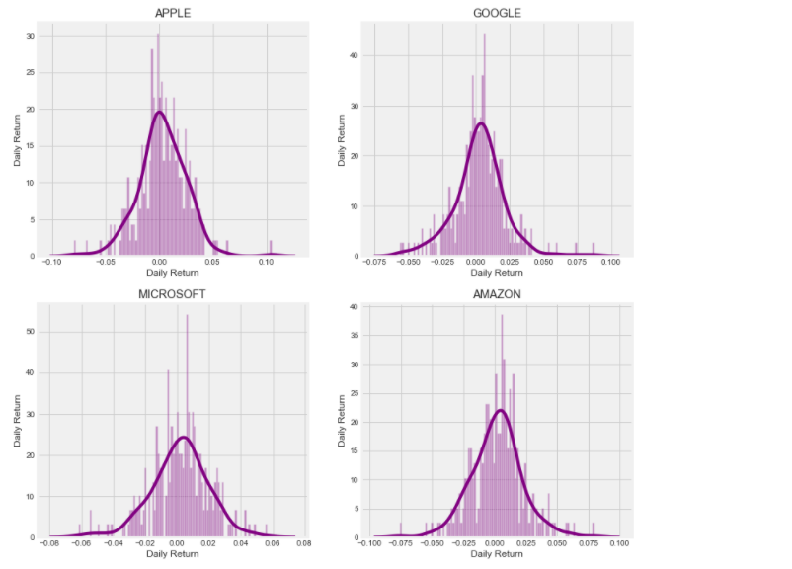

Fig. 11. average daily return

The above figures shows the risk we are putting in investing in the particular stock. The picture shows the average daily returns of the stocks on daily basis.

* 1. **Correlation between Closing prices of the Stocks**

Presently imagine a scenario where we needed to examine the profits of the multitude of stocks in our rundown. How about we feel free to assemble a DataFrame with all the ['Close'] segments for every one of the stocks dataframes. So now we can see that if two stocks are perfectly (and positivley) related with each other an immediate relationship bewteen its consistently return regards should occur.

Seaborn and pandas simplify it to repeat this relationship assessment for each possible blend of stocks in our advancement stock ticker list. We can use sns.pairplot() to thusly make this plot,

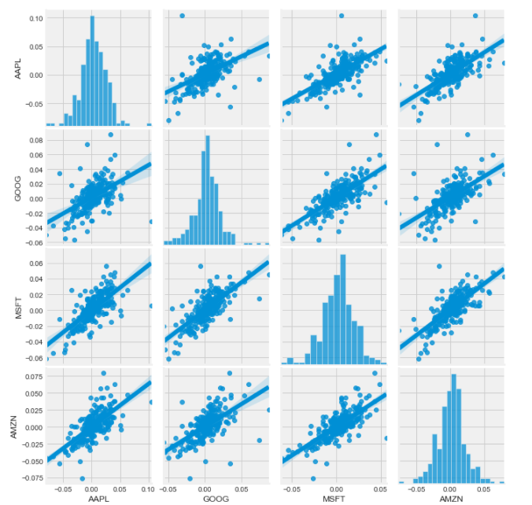

Fig. 12. Relationship between the daily returns of the stocks

Above, we will see the entirety of the normal return connections between the entirety of the stocks. A careless assessment uncovers a charming association among Google and Amazon every day returns. It very well might be beneficial to take a gander at the human correlation. While essentially calling sns.pairplot() is amazing, we may likewise utilize sns.PairGrid() to give unlimited authority over the figure, incorporating which plots go in the inclining, upper triangle, and lower triangle. Here's a clarification of how to utilize the entirety of seaborn's highlights to get this outcome.

Affiliations are likely significant considering the way that they can be moment a shrewd association so that could be mishandled in dependably practice. eg Stock data may be makes less on made zone dependably which reliant on the co-connection between police catch and establishment data. Routinely, eccentric parts which are poor in case they don't satisfy any numerical property of probabilistic autonomy. In obliging talk, co-association is replaceable with dependence. At any rate we used this in a systems of sense, co-association proposes any of various express kind of real assignments b/w the attempted parts and r separate anticipated qualities. Co-connection is the level of how at any rate two fragments are related to one another. Most by far of the standard is the Pearson co- alliance coefficient, which is unsafe just to a straight connection between two sections (which might be accessible regardless, when one variable is non-direct limitation of the other variable). Other alliance coefficients are Spearman's rank connection – have been made to be more liberal than Pearson's obviously fragile to non-direct relationship. The Correlation between different Closing prices are shown below and the Heat map is generated.

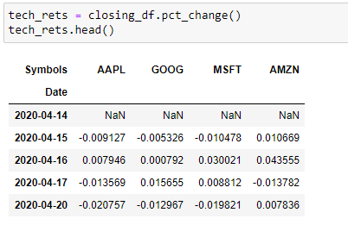

Fig. 13. Correlation between Close Price(Starting five values)

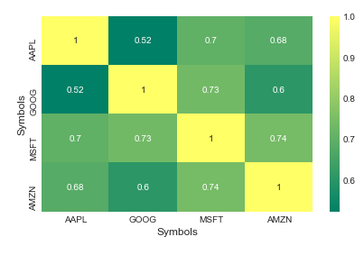

Fig. 13. Correlation Plot for Daily Returns

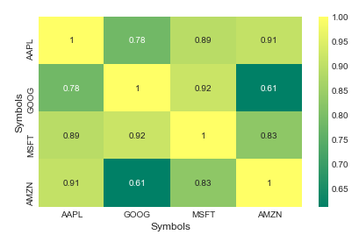

Fig. 14. Correlation Plot for Closing prices for Stocks.

* 1. **Risk in a particular stock investment**

We can quantify hazard in an assortment of ways, yet perhaps the most basic is to contrast the anticipated get back with the standard deviation of the every day returns, which we can do with the information we've gathered on day-by-day rate returns.

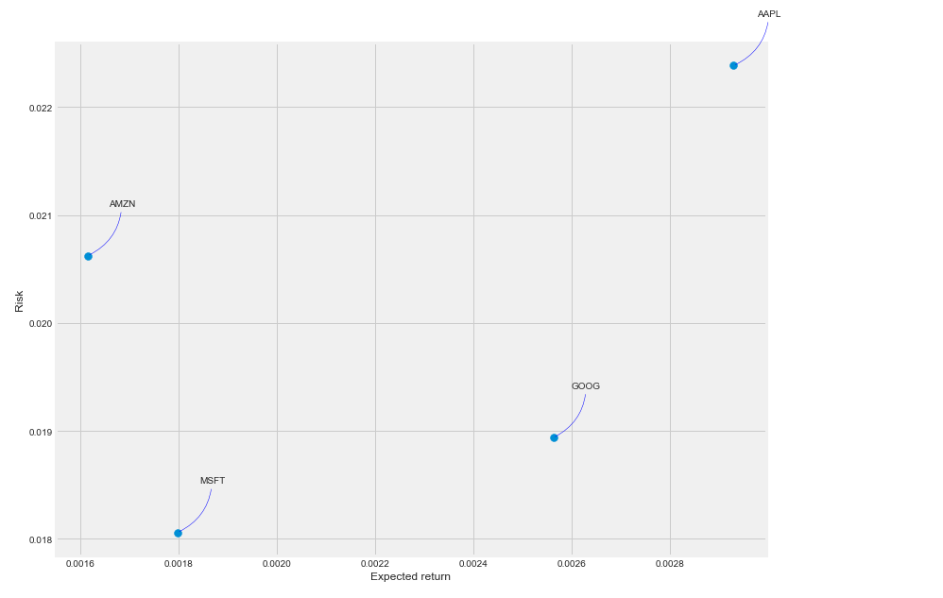

Fig. 14. Risk in investing in a particular stock

In the above figure, if the point is close to the origin there is less risk of in investing in that stock. In the above figure Microsoft stocks is the safest stock to invest and aaple is not as safe for investment.

* 1. **Preparing Data for Prediction**

The data I have taken for prediction is last nine to ten yars of stock data of Apple. i.e Data from 01-01-2012 to the present date.

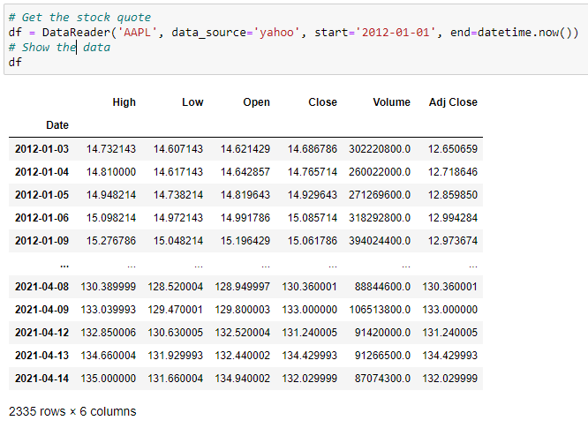

Fig. 15. Apple Finance data for prediction

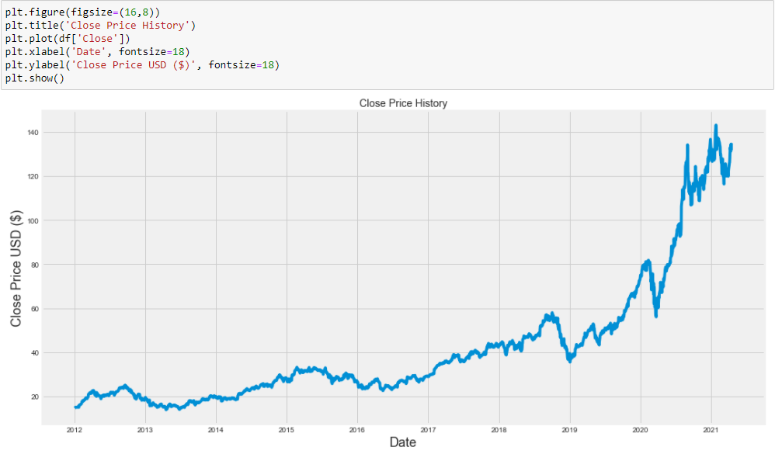

Fig. 16. Close Price Graph of Apple.

The closing price is the feature used for prediction therefor it is filtered and created a new dataset which include only the closing price.

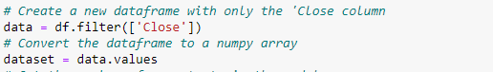

Fig. 17. Fetching Closing Price for prediction

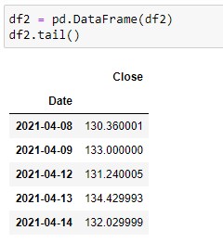

Fig. 18. Dataframe created using the Closing price

* 1. **Prediction using Long-Short-Term-Memory(LSTM)**

Normalised the data using MinMaxScaler helper function from Scikit-Learn.

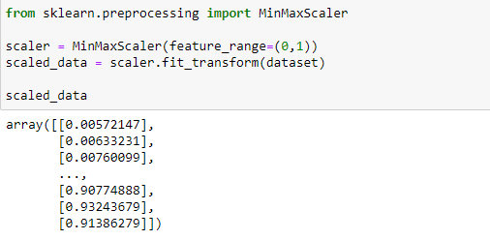

Fig. 19. Splitting the datas in training (80%) & test (20%) data for model.

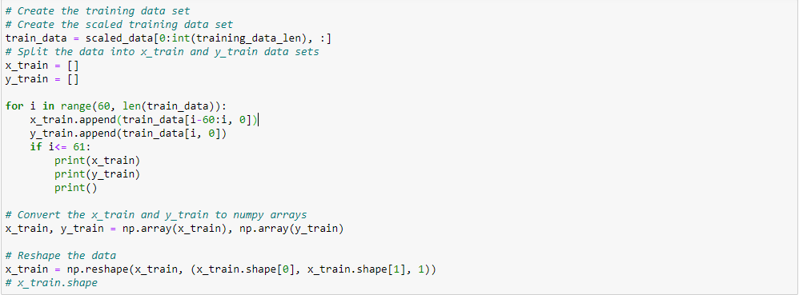

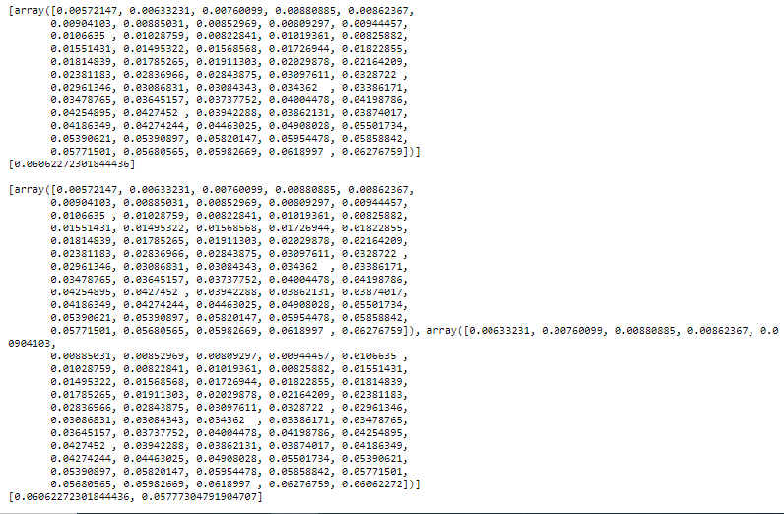

Fig. 20. Training Data

In addition to adjusting the architecture As well as changing the Neural Network's engineering, the accompanying exhaustive rundown The accompanying boundaries can be changed to improve the forecast model:

Input Parameters

* Preprocessing&Normalization
* Neural-Network-Architecture(NNA)
* Layers Numbers(the number of layer nodes which the model uses = 3)
* Node Numbes (layer uses the number of nodes; {1,3,8, 16, 32, 64, 100,128})
* Parameters for the Training
* Training-testing-Split (dataset which is used to train and to test the model; that is 80% & 2% for benchmarks and ling short term memory model)
* Sets for Validation Validation(kept constant at 0.05% of training sets)
* Batch Dimensions (how many time steps to include during a single training step; kept at 1 for basic lstm model and at 512 for improved lstm model)
* The function which is used for optimization, by minimizing error(Optimizer-Function); “Adam” is used in the entire model
* Epochs(number of times the training is repeated; which is 1 for base)

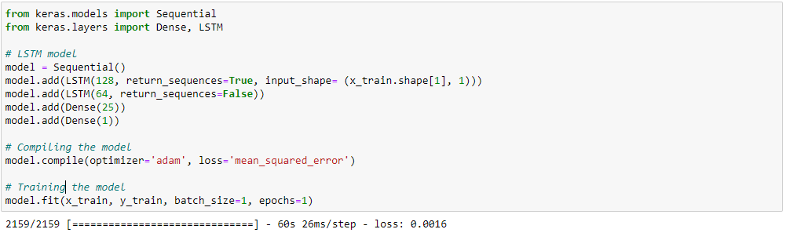

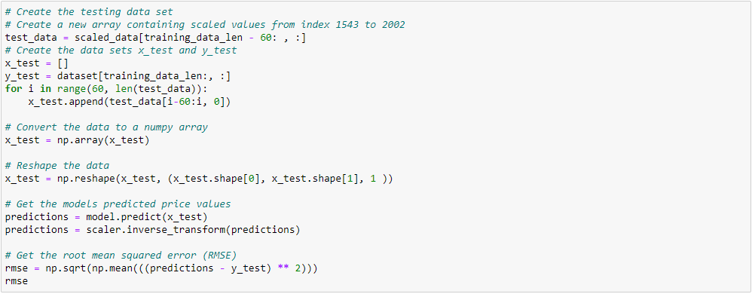

Fig. 21. Training data and testing data

* 1. **Result Analysis**

Once in the wake of plotting the results with respect to portrayals we can find the connections to get the flitting assumptions. Offered a segment of the screen chances by which the monetary supporter can inspect and expect the future stock examples of an association at a specific time. Hence, the monetary benefactors in the protections trade can use this as help to sell/buy/hold an offer.

The Plot from the LSTM Algorithms are shown below-

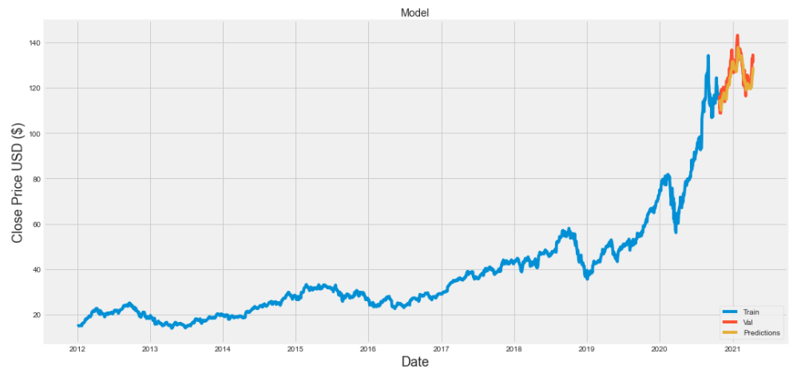

Fig. 21. Prediction usingLSTM

Blue Line: Training Data

Red Line: Actual Closing Price

Orange Line: Predicted Closing Price

The comparison between the actual values and the predicted values are shown below-

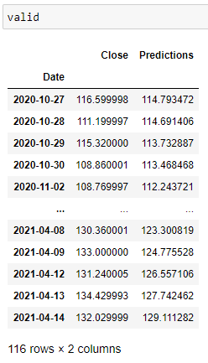

Fig. 22. Validation of the prediction

* 1. **Prediction using DecisionTree**

Creating model using decision tree regressor

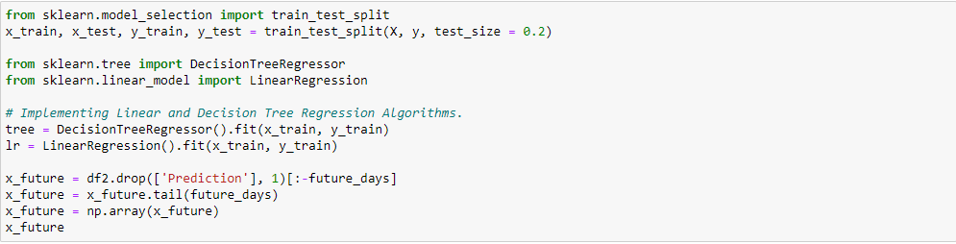

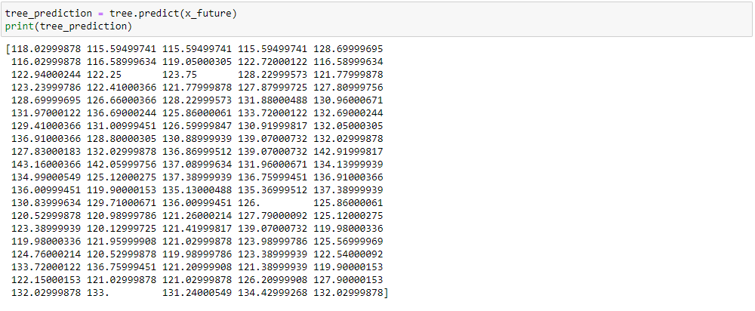

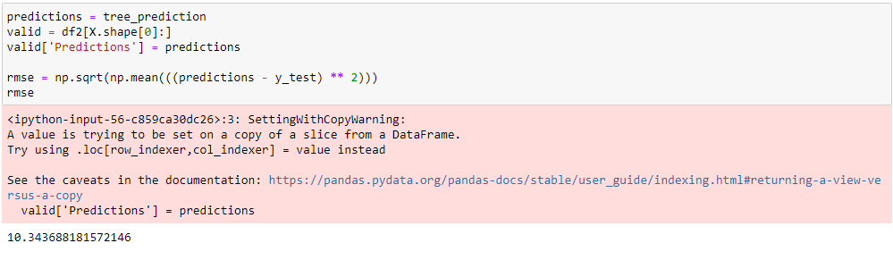

* 1. **Result Analysis**

Once in the wake of plotting the results with respect to portrayals we can find the connections to get the flitting assumptions. Offered a segment of the screen chances by which the monetary supporter can inspect and expect the future stock examples of an association at a specific time. Hence, the monetary benefactors in the protections trade can use this as help to sell/buy/hold an offer.

The Plot of Prediction by Using Decision Tree-

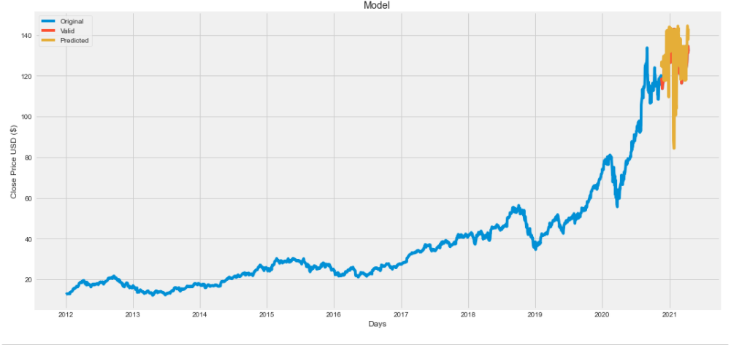

Fig. 22. Prediction using Decision Tree

Blue Line: Training Data

Red Line: Actual Closing Price

Orange Line: Predicted Closing Price

Once in the wake of plotting the results with respect to portrayals we can find the connections to get the flitting assumptions. Offered a segment of the screen chances by which the monetary supporter can inspect and expect the future stock examples of an association at a specific time. Hence, the monetary benefactors in the protections trade can use this as help to sell/buy/hold an offer.

Actual values and the predicted values comparisons are shown below-

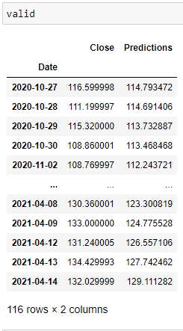

* 1. **Prediction using SVM(Support-Vector-Machines)**

Dividing our data in training (80%) and test (20%) data(Train/Test Split) for model.



Splitting Data into training and test data.

Creating the model using SVM Algorithm. Here RBF Kernel is used for Creating SVM Model. The parameter C, which is shared by all SVM kernels, trades off misclassification of training examples for the decision surface's simplicity. A low C smoothes the judgement board, while a high C aims to correctly distinguish all training instances. The gamma value indicates how powerful a single training example is. The bigger the gamma, the closer the other examples would be in order to be influenced.

The SVM's efficiency is highly dependent on the option of C and gamma.



Model Creation using SVM

* 1. **Testing the model**

Here we are getting the Confidence of 0.9033204583267008

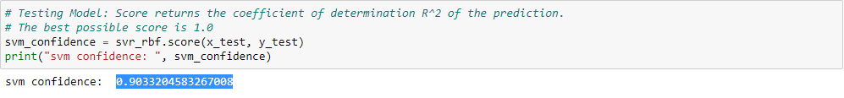

Testing the SVM Model



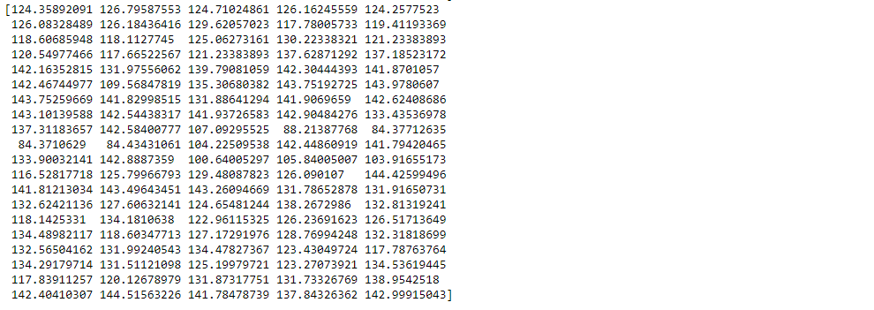

Results of Prediction for the next 100 days

* 1. **Result Analysis**

Once in the wake of plotting the results with respect to portrayals we can find the connections to get the flitting assumptions. Offered a segment of the screen chances by which the monetary supporter can inspect and expect the future stock examples of an association at a specific time. Hence, the monetary benefactors in the protections trade can use this as help to sell/buy/hold an offer.

The Plot of Prediction by Using SVM-

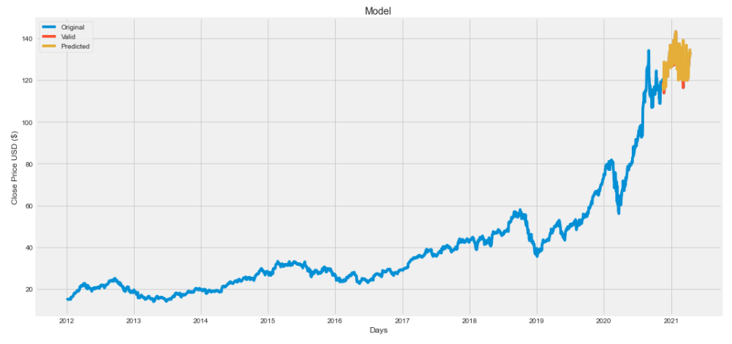

Fig. 23. Prediction using SVM

Blue Line: Training Data

Red Line: Actual Closing Price

Orange Line: Predicted Closing Price

The following table shows the difference between the actual and predicted values:

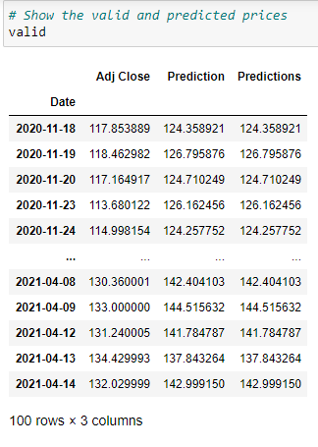

Validation

1. **CONCLUSION**

With the help of machine learning algorithm, using python as core we can predict the Stock prices of the desired stocks. We attempted to construct a simulation model for forecasting stock market trends based on technical analysis using historical time series stock market data and Machine Learning Algorithms. The results of the experiments revealed that the LSTM, SVM, and Decision tree models could predict stock price indices in the short term. This may aid stock market investors in making profitable investment decisions, such as whether to buy, sell, or hold a stock. From the Plots from the prediction we can clearly observe that the LSTM Produced the best results as compared to the other two methods(SVM and Decision tree). There is not much difference in the actual value and predicted value as we can see the deflection between the red line(Actual Value) and Orange Line(Predicted Value). Also the Root-Mean-Square-Error least in the LSTM(4.042720851399828) as Compared to other two methods(10.343688181572146 for Decision tree and 8.044581251399828 for SVM). In contrast to SVM and Decision Tree, the LSTM model can do reasonably well in short-term prediction with current forecasting techniques.

## References

[1]. Chen, N., Roll, R., & Ross, S. (1986). Economic Forces and the Stock Market. *The Journal of Business,* *59*(3), 383-403. Retrieved April 20, 2021, from http://www.jstor.org/stable/2352710

[2]. Abu-Mostafa, Y.S., Atiya, A.F. Introduction to financial forecasting. Appl Intell 6, 205–213 (1996). https://doi.org/10.1007/BF00126626

[3]. N. Ancona. (1999). *Classification Properties of Support Vector Machines for Regression.*

[4]. Kyoung-jae Kim,Financial time series forecasting using support vector machines, Neurocomputing, Volume 55, Issues 1–2, 2003, Pages 307-319, ISSN 0925-2312, <https://doi.org/10.1016/S0925-2312(03)00372-2>.

[5]. Huang, Wei & Nakamori, Yoshiteru & Wang, Shouyang. (2005). Forecasting stock market movement direction with support vector machine.. Computers & OR. 32. 2513-2522.

[6]. Chen, W. H., Shih, J. Y., & Wu, S. (2006). Comparison of support-vector machines and back propagation neural networks in forecasting the six major Asian stock markets. International Journal of Electronic Finance, 1(1), 49-67. https://doi.org/10.1504/IJEF.2006.008837

[7]. Robert P. Schumaker and Hsinchun Chen. 2009. A quantitative stock prediction system based on financial news. Inf. Process. Manage. 45, 5 (September, 2009), 571–583. DOI:https://doi.org/10.1016/j.ipm.2009.05.001

[8]. Shen, S., Jiang, H., & Zhang, T. (2012). Stock Market Forecasting Using Machine Learning Algorithms.

[9]. Debashish Das and Mohammad Shorif Uddin. (2013). *Data Mining And Neural Network Techniques In Stock Market Prediction: A Methodological Review*. International Journal of Artificial Intelligence & Applications (IJAIA), Vol.4, No.1, January 2013. DOI : 10.5121/ijaia.2013.4109

[10]. Hu, Z., Zhu, J., & Tse, K. (2013). Stocks market prediction using Support Vector Machine. *2013 6th International Conference on Information Management, Innovation Management and Industrial Engineering, 2*, 115-118.

[11. Hegazy, Osman & Soliman, Omar S. & Abdul Salam, Mustafa. (2013). A Machine Learning Model for Stock Market Prediction. International Journal of Computer Science and Telecommunications. 4. 17-23.

[12]. Adaptive selection of US stocks with neural nets. In: Deboeck GJ, editor. Trading on the edge: neural, genetic, and fuzzy systems for chaotic financial markets. New York, Wiley Hall JW, 2017.

[13]. Vanukuru, Kranthi. (2018). Stock Market Prediction Using Machine Learning. 10.13140/RG.2.2.12300.77448.

[14]. X. Lu, B. Wang, X. Zheng and X. Li, "Exploring Models and Data for Remote Sensing Image Caption Generation," in *IEEE Transactions on Geoscience and Remote Sensing*, vol. 56, no. 4, pp. 2183-2195, April 2018, doi: 10.1109/TGRS.2017.2776321.

[15]. Torres, Edgar & Alvarez, Myriam & Torres, Edgar & Yoo, Sang Guun. (2019). Stock Market Data Prediction Using Machine Learning Techniques: Proceedings of ICITS 2019. 10.1007/978-3-030-11890-7_52.

[16]. Sanjana, S. & Shriya, V. & Vaishnavi, Gururaj & Ashwini, K.. (2020). A review on various methodologies used for vehicle classification, helmet detection and number plate recognition. Evolutionary Intelligence. 10.1007/s12065-020-00493-7.

[17]. "STOCK MARKET PREDICTION SYSTEM USING MACHINE LEARNING APPROACH", International Journal of Science & Engineering Development Research (www.ijsdr.org), ISSN:2455-2631, Vol.4, Issue 10, page no.139 - 141, October-2019, Available :http://www.ijsdr.org/papers/IJSDR1910027.pdf

[18]. Stock Market Prediction Using Machine Learning Algorithms K. Hiba Sadia, Aditya Sharma, Adarrsh Paul, SarmisthaPadhi, Saurav Sanyal, 2019.

[19]. Automated Stock Price Prediction Using Machine Learning, Mariam Moukalled Wassim El-Hajj Mohamad Jaber, 2019.

[20]. STOCK MARKET PREDICTION USING MACHINE LEARNING AND DEEP LEARNING TECHNIQUES, Prerana C, Pratheeksha Mahishi J, N Tahmin Taj, Anusha B Shetty, Madhu B R, 2020

[21]. Sharma, Ashish & Bhuriya, Dinesh & Singh, Upendra. (2017). Survey of stock market prediction using machine learning approach. 506-509. 10.1109/ICECA.2017.8212715.

[22]. M. Usmani, S. H. Adil, K. Raza and S. S. A. Ali, "Stock market prediction using machine learning techniques," 2016 3rd International Conference on Computer and Information Sciences (ICCOINS), 2016, pp. 322-327, doi: 10.1109/ICCOINS.2016.7783235.

[23]. I. Parmar et al., "Stock Market Prediction Using Machine Learning," 2018 First International Conference on Secure Cyber Computing and Communication (ICSCCC), 2018, pp. 574-576, doi: 10.1109/ICSCCC.2018.8703332.

[24]. Khan, W., Ghazanfar, M., Azam, M., Karami, A., Alyoubi, K., & Alfakeeh, A. (2020). Stock market prediction using machine learning classifiers and social media, news. Journal of Ambient Intelligence and Humanized Computing, OnlineFirst, 1-24.

[25]. P. D. Yoo, M. H. Kim and T. Jan, "Machine Learning Techniques and Use of Event Information for Stock Market Prediction: A Survey and Evaluation," International Conference on Computational Intelligence for Modelling, Control and Automation and International Conference on Intelligent Agents, Web Technologies and Internet Commerce (CIMCA-IAWTIC'06), 2005, pp. 835-841, doi: 10.1109/CIMCA.2005.1631572. [26]. Stock Market Prediction Using Hidden Markov Models, Aditya Gupta, 2012.

[27]. Robert P. Schumaker and Hsinchun Chen. 2009. Textual analysis of stock market prediction using breaking financial news: The AZFin text system. ACM Trans. Inf. Syst. 27, 2, Article 12 (February 2009), 19 pages. DOI:https://doi.org/10.1145/1462198.1462204

[28]. Lee, Tae & Cho, Joon & Kwon, Deuk & Sohn, So. (2018). Global stock market investment strategies based on financial network indicators using machine learning techniques. Expert Systems with Applications. 117. 10.1016/j.eswa.2018.09.005.

[29]. Qian, B., Rasheed, K. Stock market prediction with multiple classifiers. Appl Intell 26, 25–33 (2007). https://doi.org/10.1007/s10489-006-0001-7

[30]. Patel, Jigar & Shah, Sahil & Thakkar, Priyank & Kotecha, Ketan. (2014). Predicting stock market index using fusion of machine learning techniques. Expert Systems with Applications. 42. 10.1016/j.eswa.2014.10.031.



